**COMP122 – Winter2017 Assigment3 _ Section 06**

**Sargis Nahapetyan: 300904358**

**Question 1:**

Correct answers are: A, B, C

**Question 2:**

Correct answer is: D

**Question 3:**

**Tables added:**

INSERT INTO my_employees_above_avg(employee_id, first_name, last_name, salary) VALUES(5454, 'ffgf','fdfdf', 6500)

INSERT INTO my_employees_above_avg(employee_id, first_name, last_name, salary) VALUES(2222, 'Man','Guy', 324)

INSERT INTO my_employees_above_avg(employee_id, first_name, last_name, salary) VALUES(2222, 'Man','Guy', 324)

INSERT INTO my_employees_above_avg( first_name, last_name) VALUES('John’,‘Smith’)

INSERT INTO my_employees_above_avg( first_name, last_name) VALUES('Jon','Sith')

**A:**

select employee_id, first_name, last_name, salary

from my_employees_above_avg



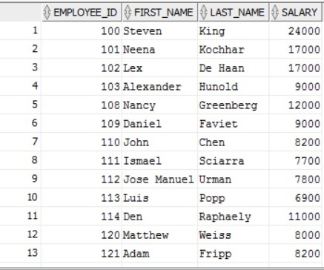

**B:**

update my_employees_above_avg

set salary = salary + 100

where (salary BETWEEN 7000 AND 12000)

AND LAST_NAME like 'B%';

select employee_id, first_name, last_name, salary

from my_employees_above_avg

where (SALARY BETWEEN 7000 AND 12000)

AND LAST_NAME like 'B%';

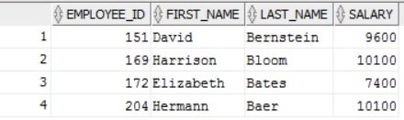

**C:**

Four employees where updated:

1. David Bernstein
2. Harrison Bloom
3. Elizabeth Bates
4. Hermann Baer

**D:**



